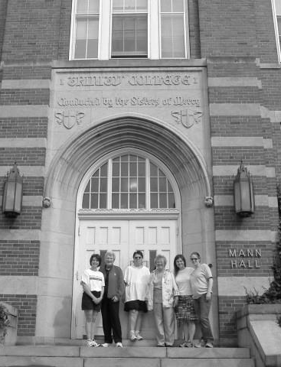
Trinity College of Vermont Reunion 2019
Alumni Luncheon and Annual Meeting.
June 1, 2019 11 AM to 3 PM
to be held at
The Hampton Inn. 42 Lower Mountain View Dr. Colchester, VT
Come reconnect with friends and share memories at the

There will be a basket raffle to benefit the Scholarship fund.
Coming into town on Friday night (May 31, 2019)?
Before heading out to dinner, why not stop by for an informal gathering at
Duke’s Public House starting at 5:00pm ~located in Delta Hotels Marriott
(formerly Trader Duke’s Hotel, 1117 Williston Rd, South Burlington, VT 05403)

For online registration and payment, visit WWW.TCVT.NET
There, you will also find a link for room reservations at Delta Hotels Marriott
Room reservation deadline: MAY 1, 2019. _____________________________________________
REGISTRATION FORM
NAME_______________________________________ Class year_______
GUEST_______________________________________
Mailing Address: __________________________________________
Telephone _________________ Email_________________________
Opt out of paper mailing, receive by email only: YES______ NO_______
Luncheon: $45.00 x ___ (number of persons attending) = ______
Choice: Baked Cod ______ (Coated with lemon, dill, and butter crust)
Chicken Marsala ____ (Boneless breast of chicken, topped with creamy mushroom and Marsala wine sauce) GF
Stuffed Portabella Mushroom ____ (Stuffed with spinach, ricotta cheese, and roasted red peppers) GF
Hearth Keepers donation: _________ Mercy Connections-Women in Transition: ________
Mail registration form and check to: TCVTAAF P.O. Box 5186, Essex Junction, VT 05453
Registrations must be postmarked by May 15, 2019

